Angle finder
# Source: AI Source: Provided by: [Data Path: Persons Table -> ID Column: 1, Name_En Column: Motasem Essam] -> From: [ChatGPT] on [7/17/2026]
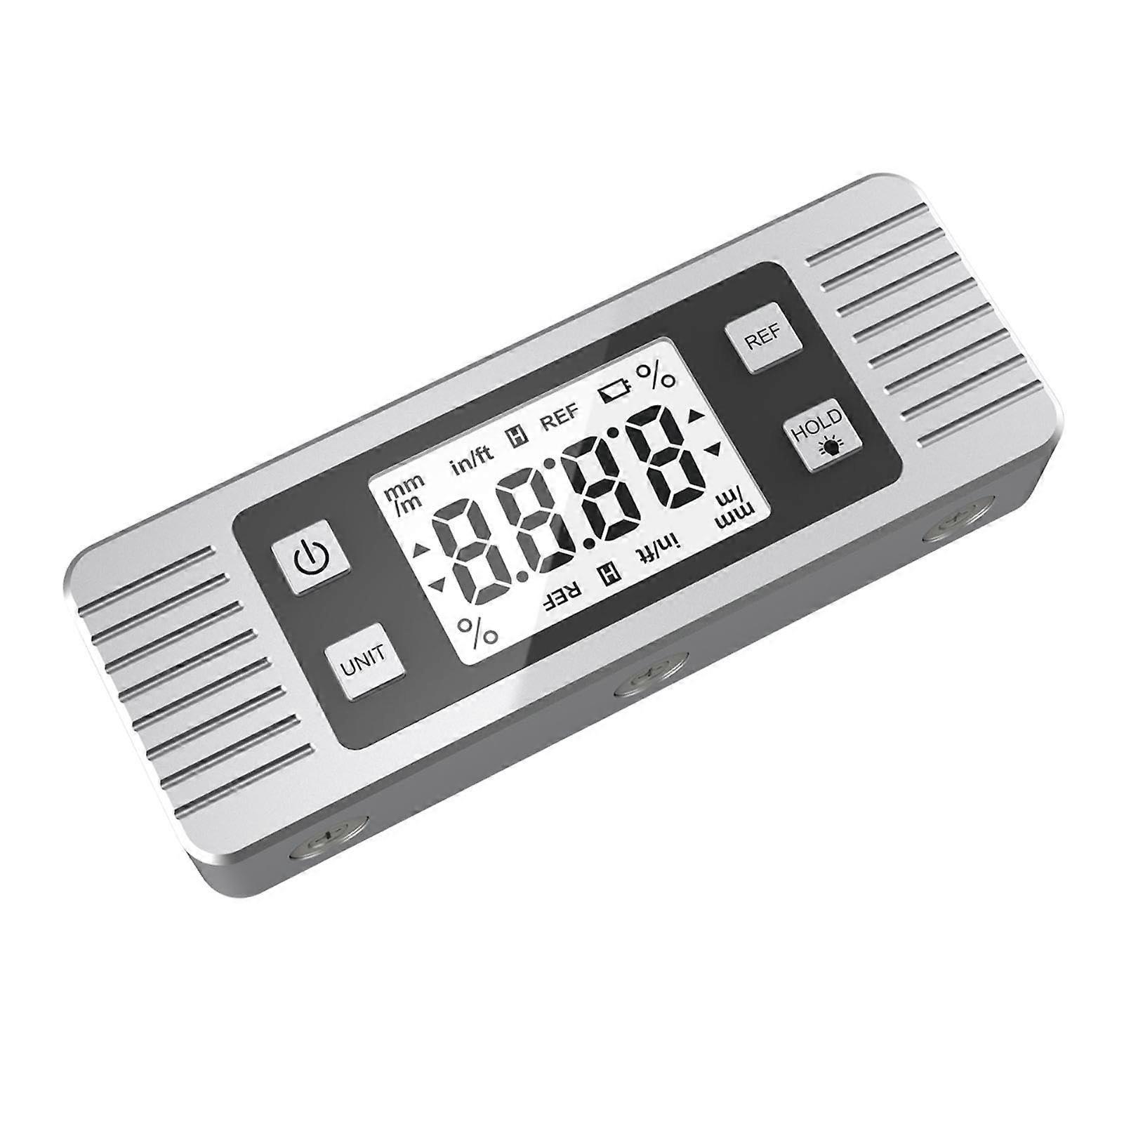
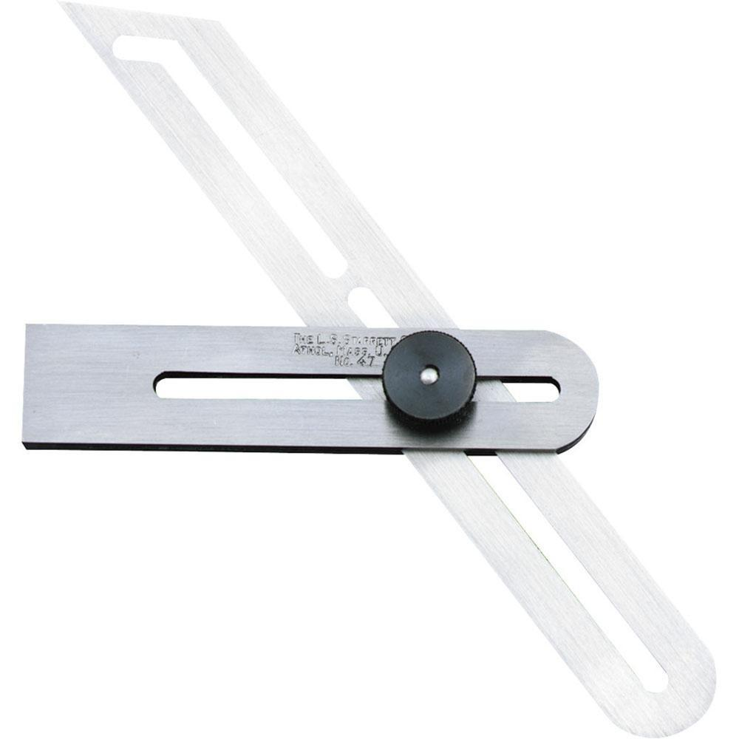
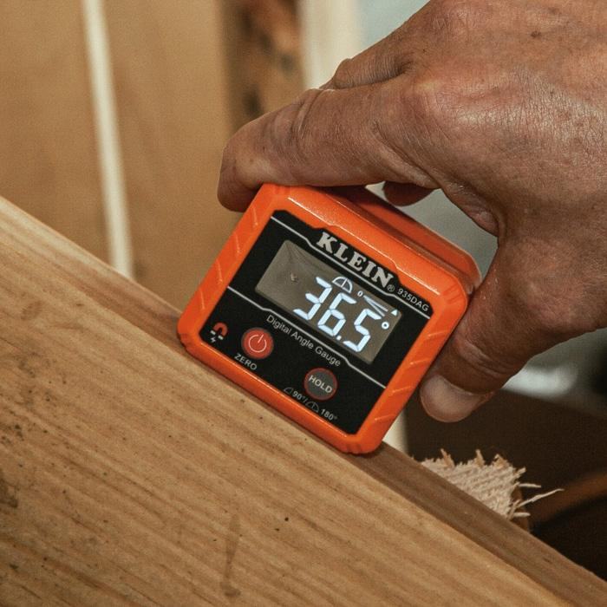
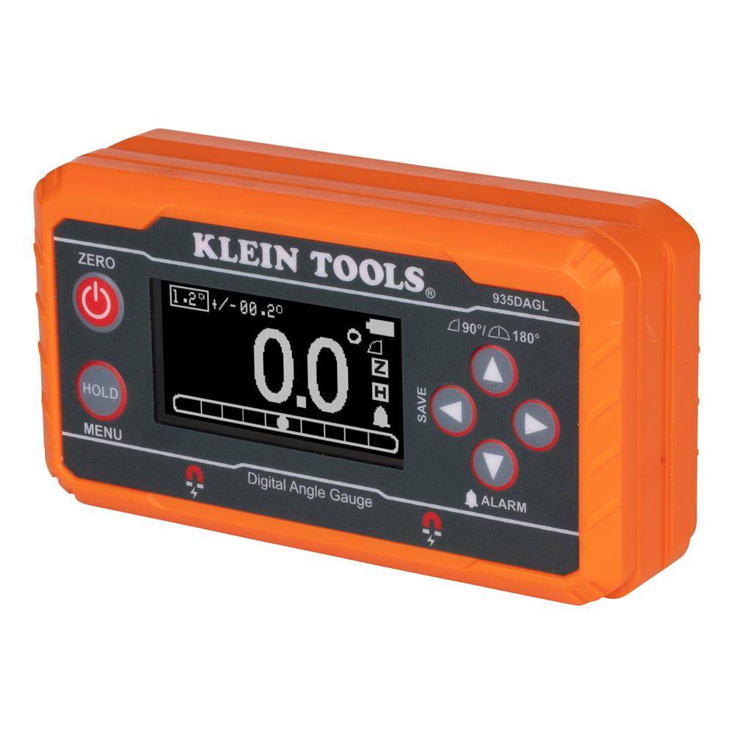
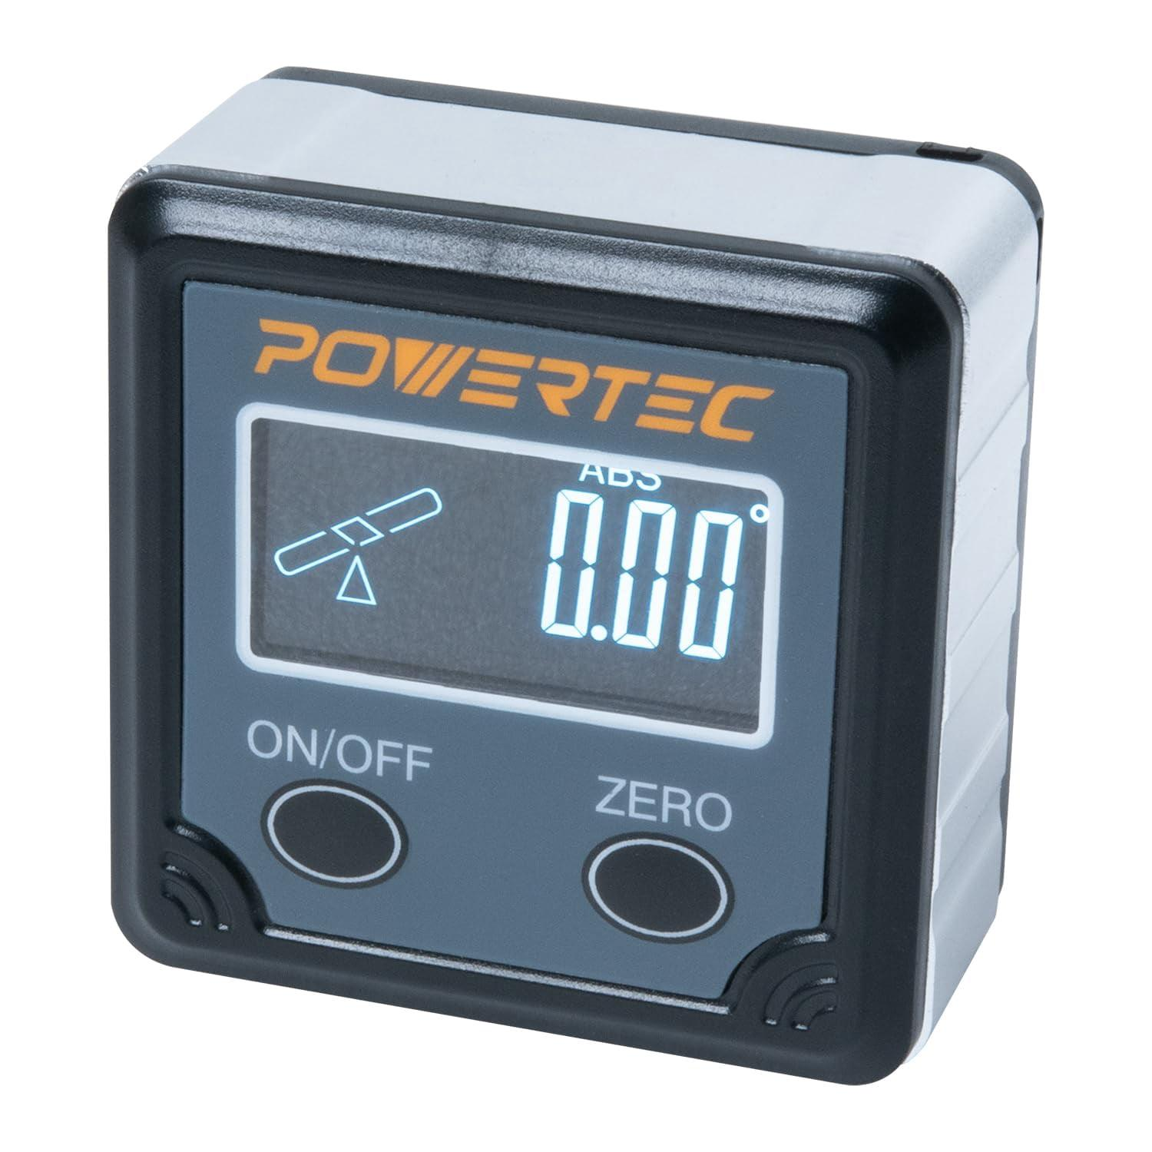
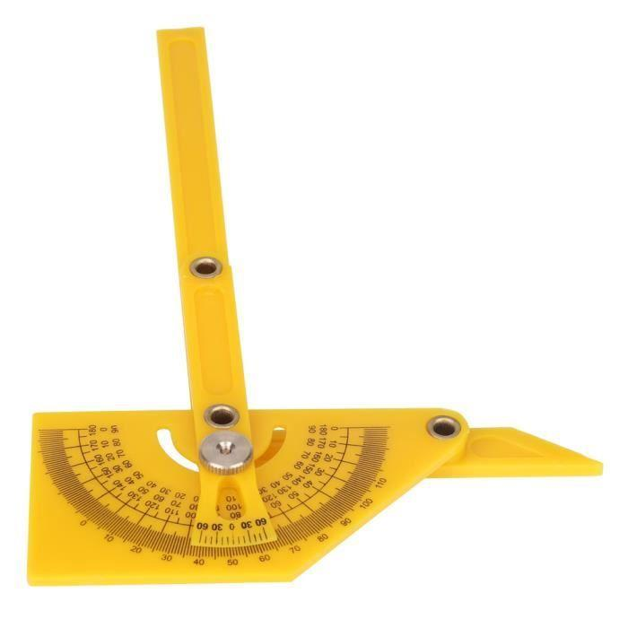
An Angle Finder is a measuring instrument used to measure, set, transfer, and verify angles quickly and accurately. Depending on the design, an angle finder may be manual or digital, and it is widely used in construction, carpentry, woodworking, engineering, machining, metalworking, surveying, and quality inspection.
Unlike a standard protractor, many angle finders are designed to measure angles directly on objects and structures rather than on paper.

Definition
# Source: AI Source: Provided by: [Data Path: Persons Table -> ID Column: 1, Name_En Column: Motasem Essam] -> From: [ChatGPT] on [7/17/2026]
An Angle Finder is a measuring instrument designed to determine, transfer, and set the angle between two intersecting surfaces or lines.

Purpose
# Source: AI Source: Provided by: [Data Path: Persons Table -> ID Column: 1, Name_En Column: Motasem Essam] -> From: [ChatGPT] on [7/17/2026]
An Angle Finder is used to:
- Measure angles.
- Transfer angles.
- Set machine angles.
- Verify construction angles.
- Measure roof slopes.
- Measure pipe angles.
- Align equipment.
- Assist in layout and inspection.

Principle of Operation
# Source: AI Source: Provided by: [Data Path: Persons Table -> ID Column: 1, Name_En Column: Motasem Essam] -> From: [ChatGPT] on [7/17/2026]
The instrument measures the angle between two arms or surfaces.
- Manual models use adjustable arms and engraved scales.
- Digital models use electronic sensors (inclinometers) and display the measured angle on an LCD screen.

Main Components
# Source: AI Source: Provided by: [Data Path: Persons Table -> ID Column: 1, Name_En Column: Motasem Essam] -> From: [ChatGPT] on [7/17/2026]
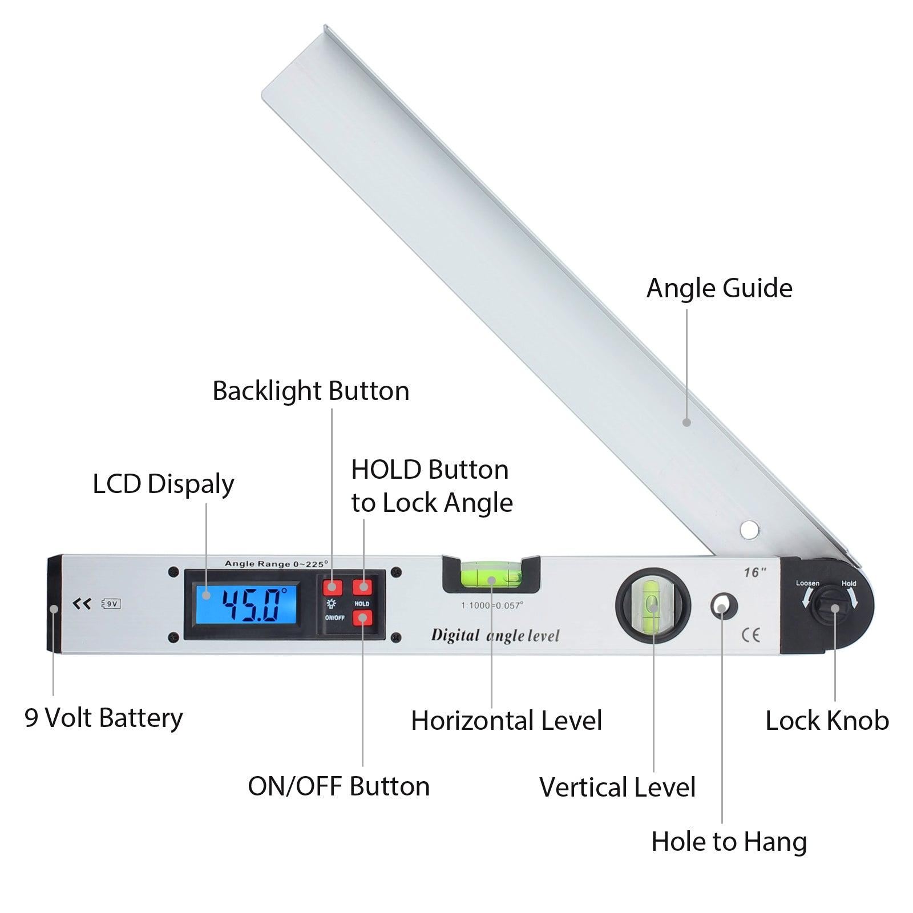
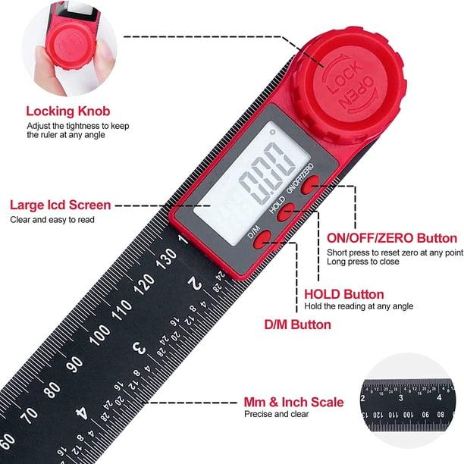
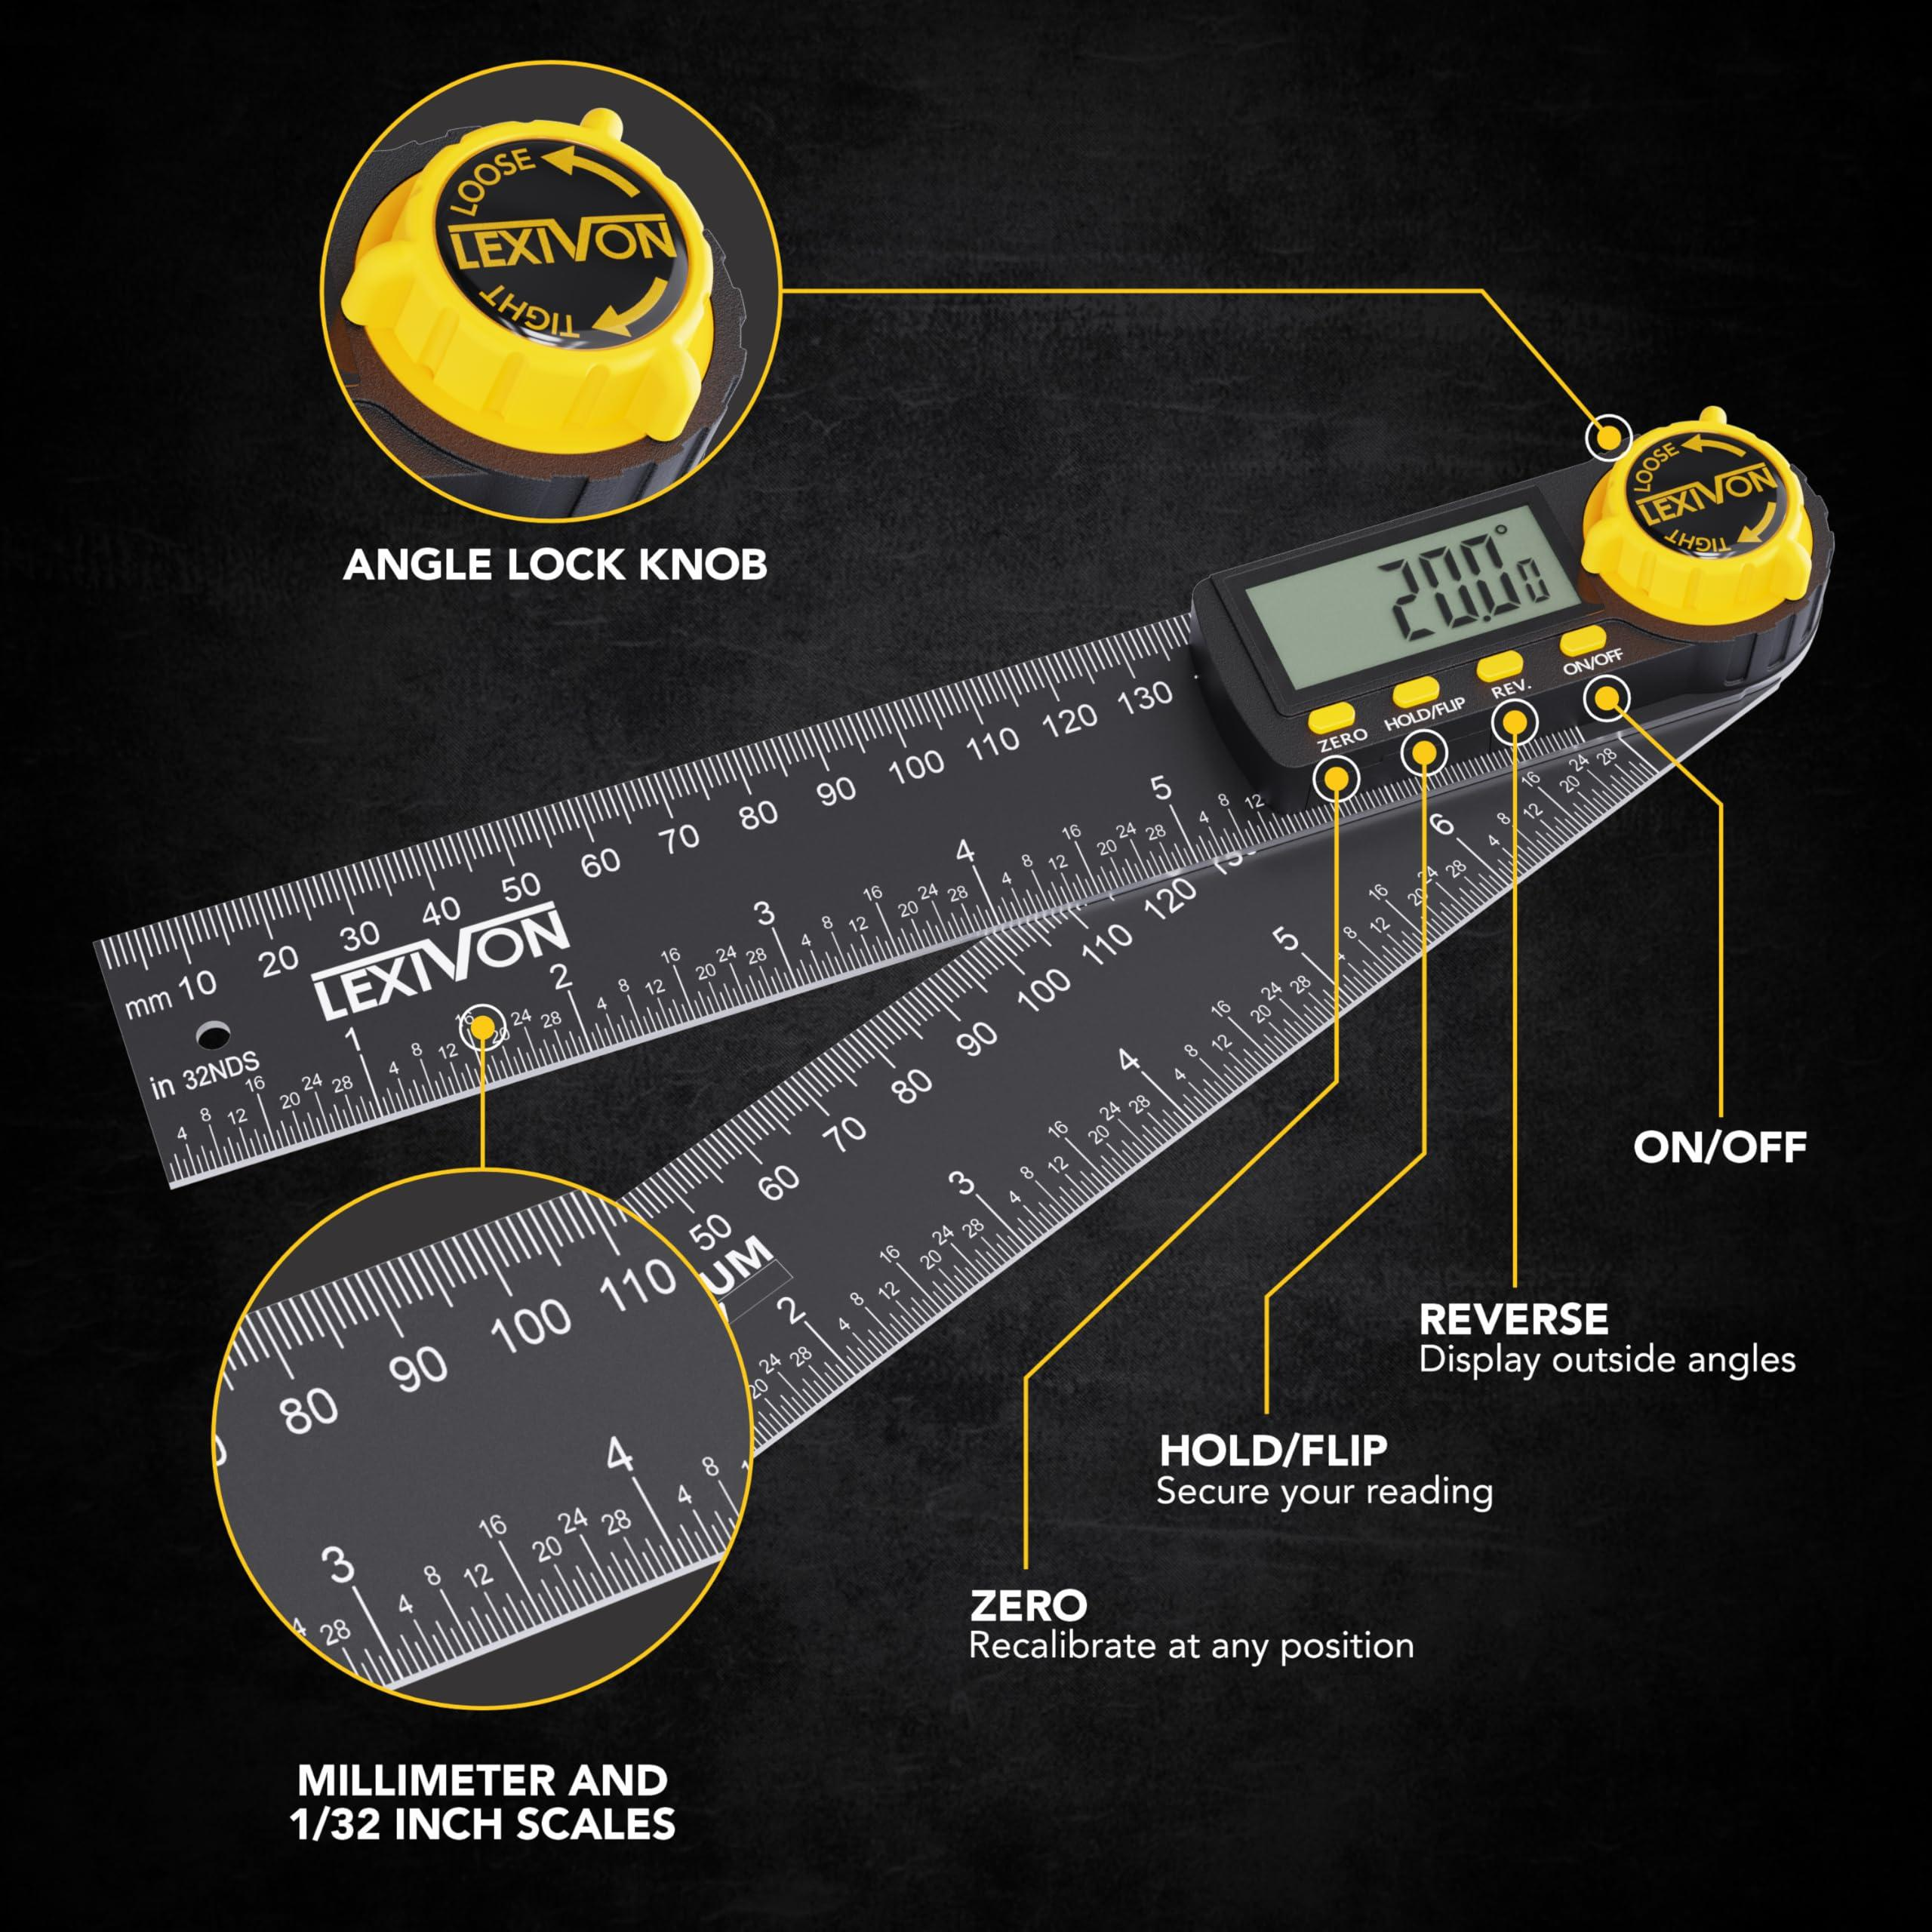
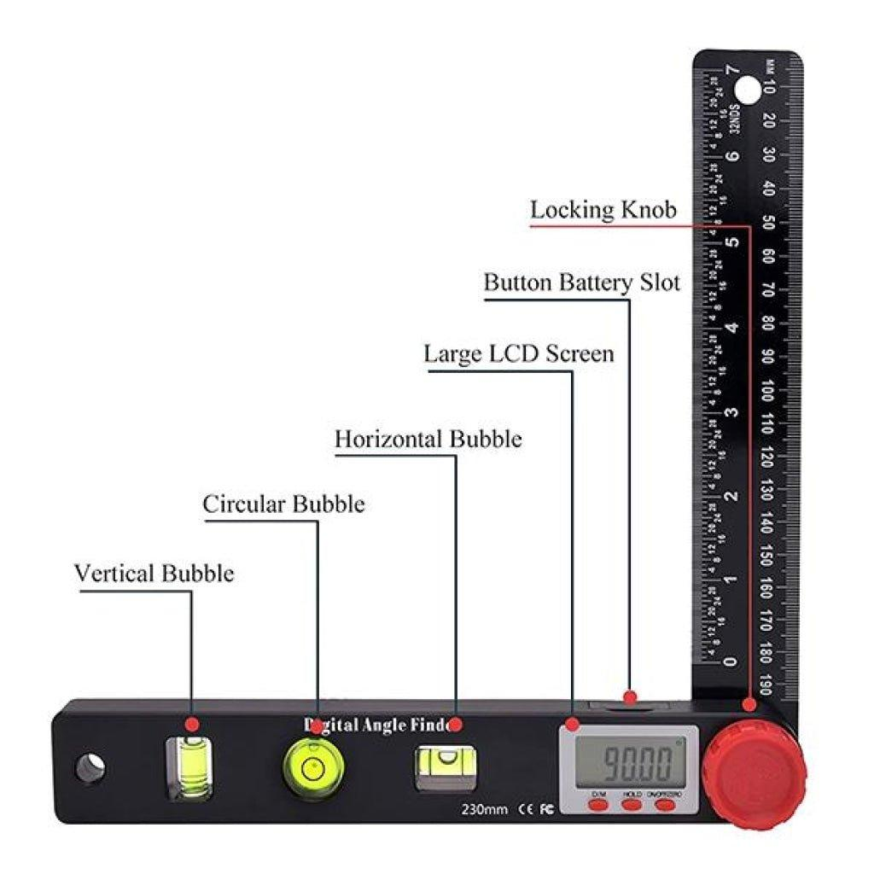
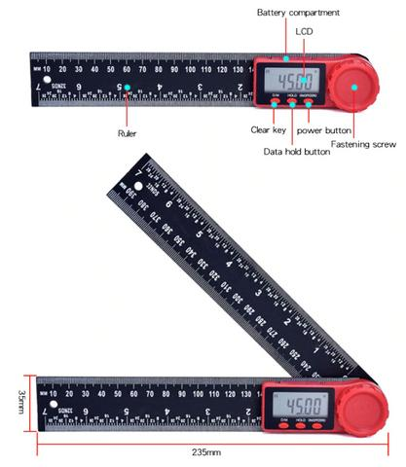
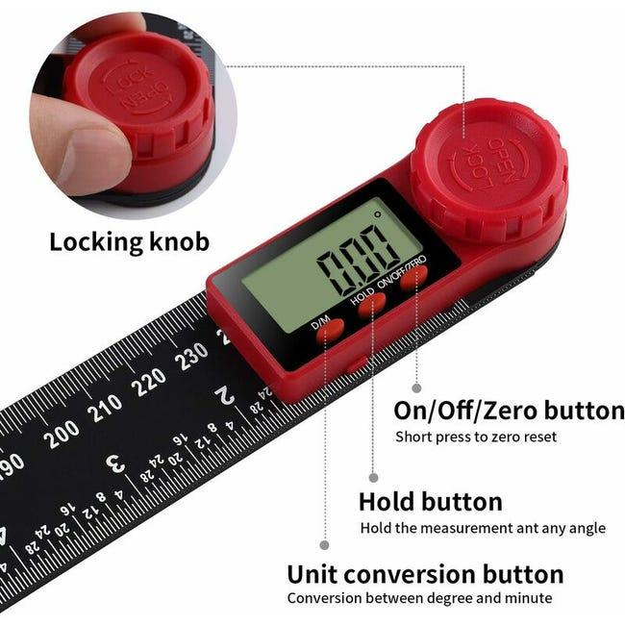
A typical Angle Finder consists of:
- Measuring arms
- Pivot joint
- Locking mechanism
- Angle scale or LCD display
- Electronic sensor (digital models)
- Battery compartment (digital models)

Types of Angle Finders

1. Manual Angle Finder
# Source: AI Source: Provided by: [Data Path: Persons Table -> ID Column: 1, Name_En Column: Motasem Essam] -> From: [ChatGPT] on [7/17/2026]
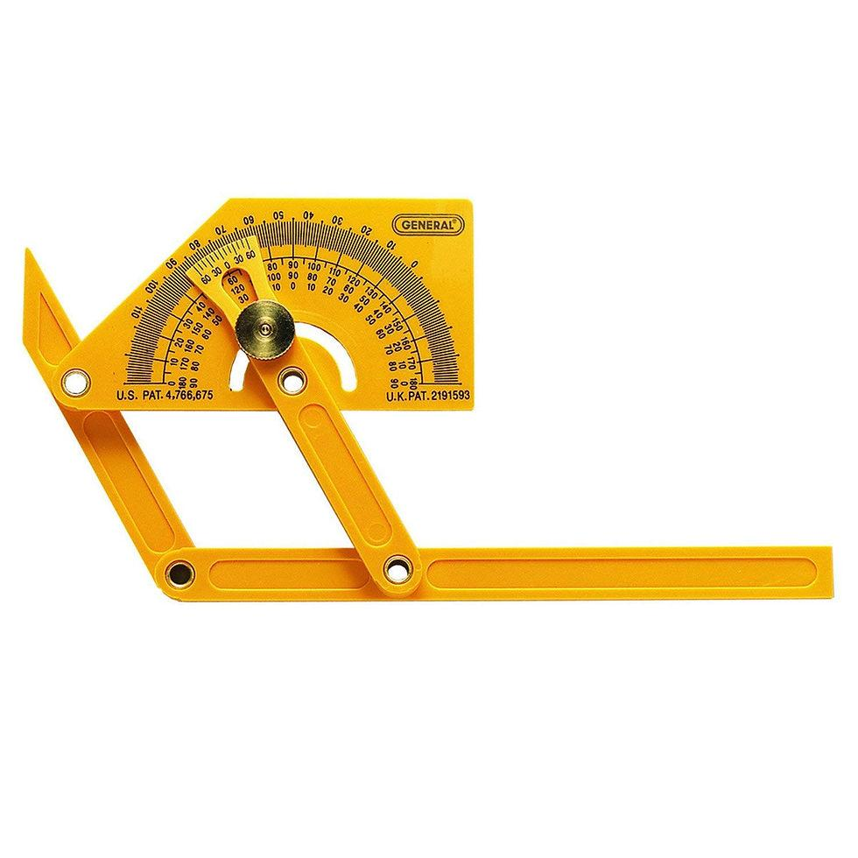
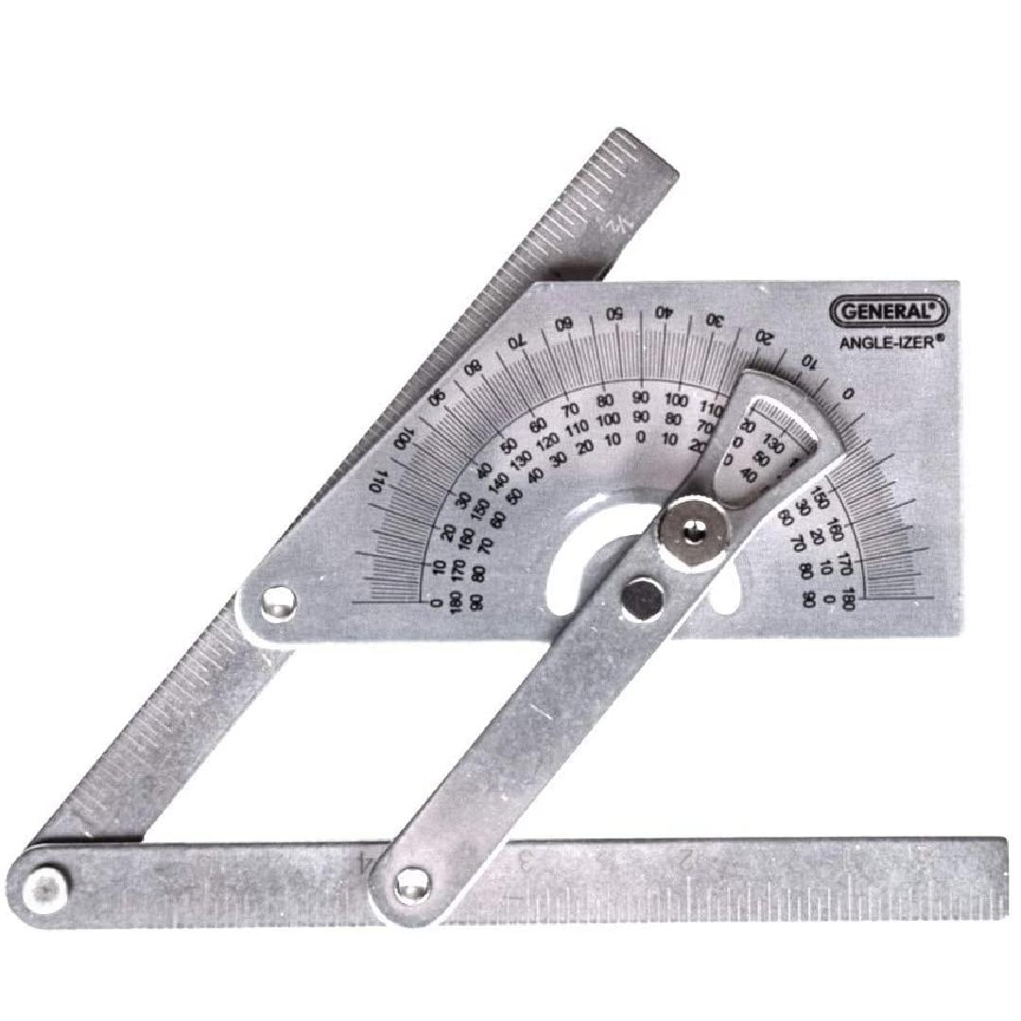
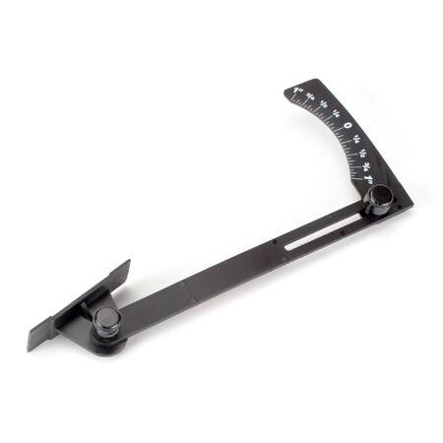
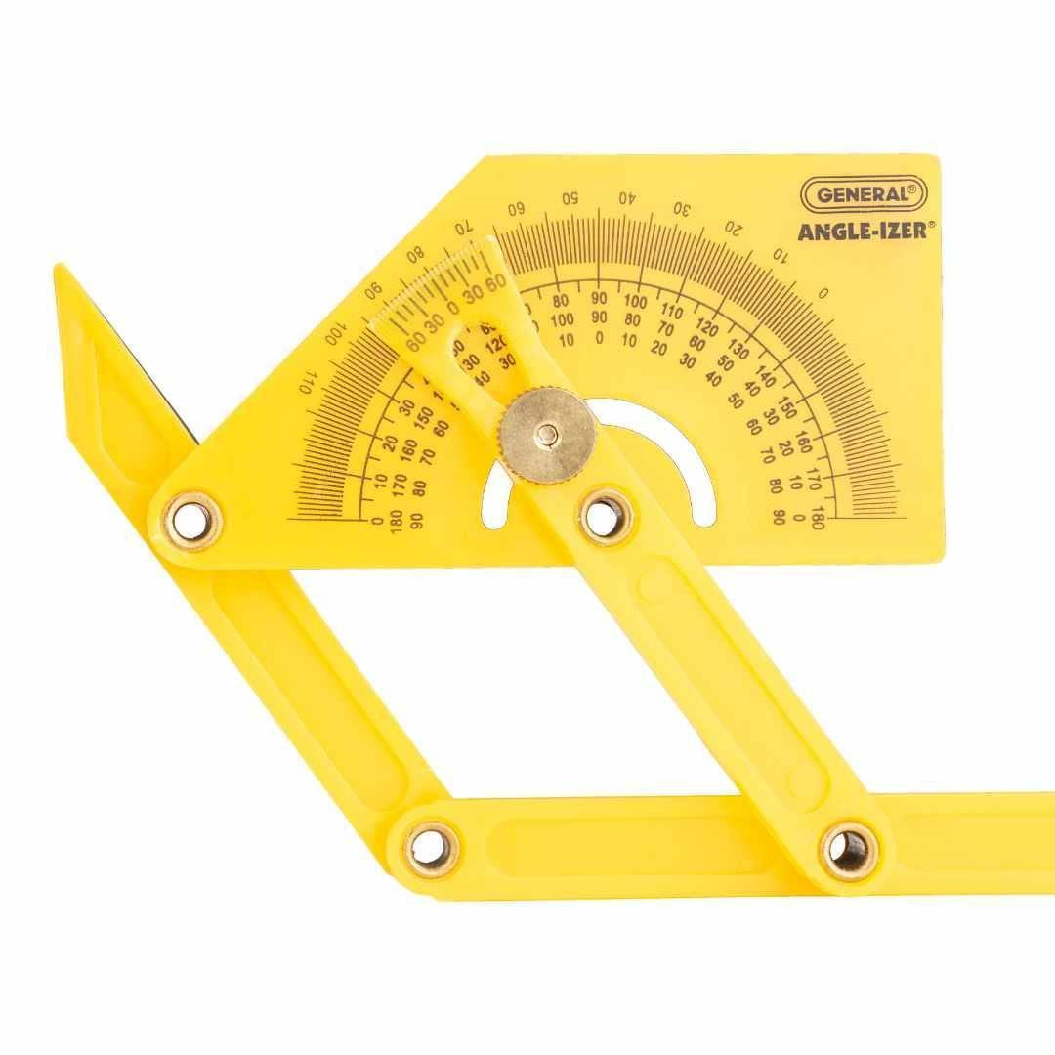
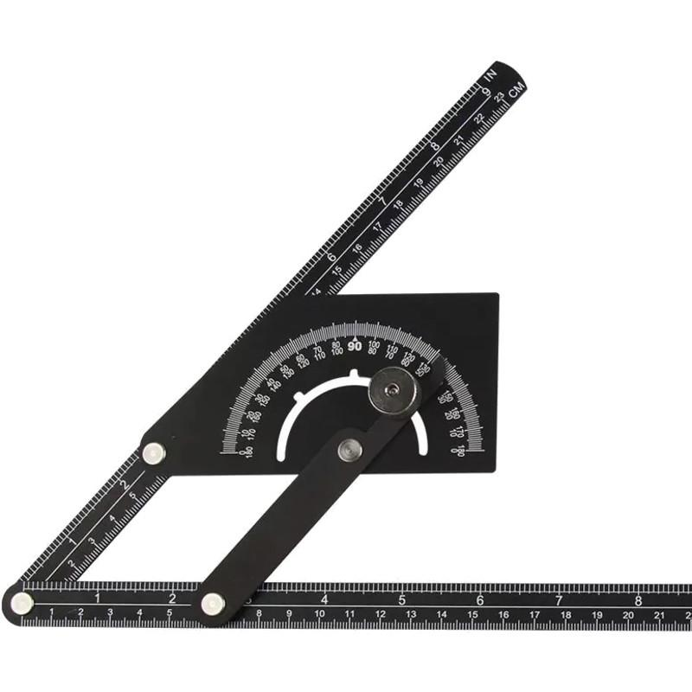
Description
A simple mechanical tool with pivoting arms that measures and transfers angles manually.
Features
- Adjustable arms
- Locking screw
- Graduated scale
- No batteries required
Applications
- Carpentry
- Woodworking
- General construction

2. Digital Angle Finder
# Source: AI Source: Provided by: [Data Path: Persons Table -> ID Column: 1, Name_En Column: Motasem Essam] -> From: [ChatGPT] on [7/17/2026]
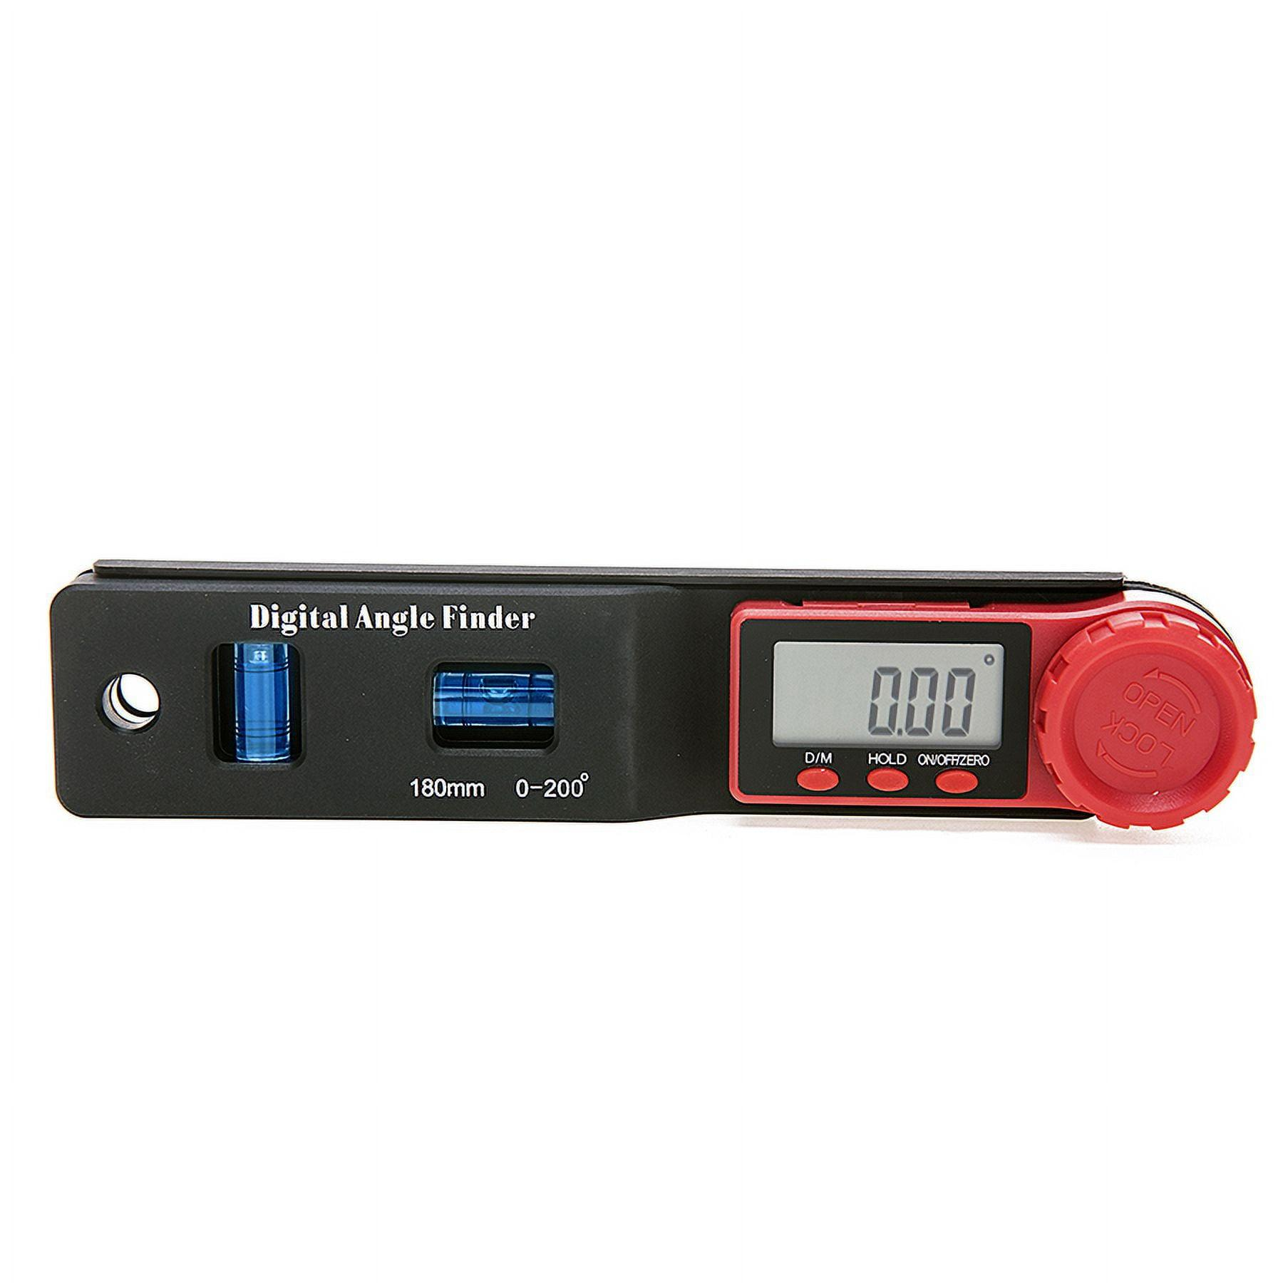
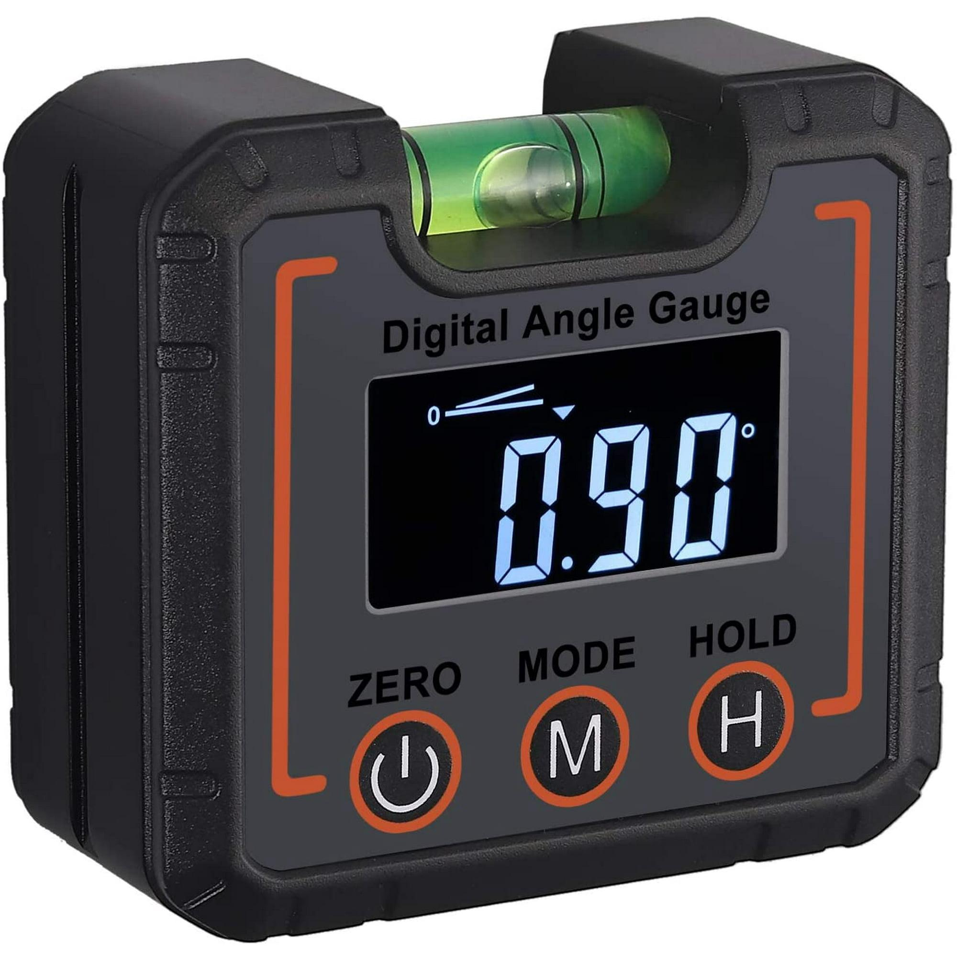
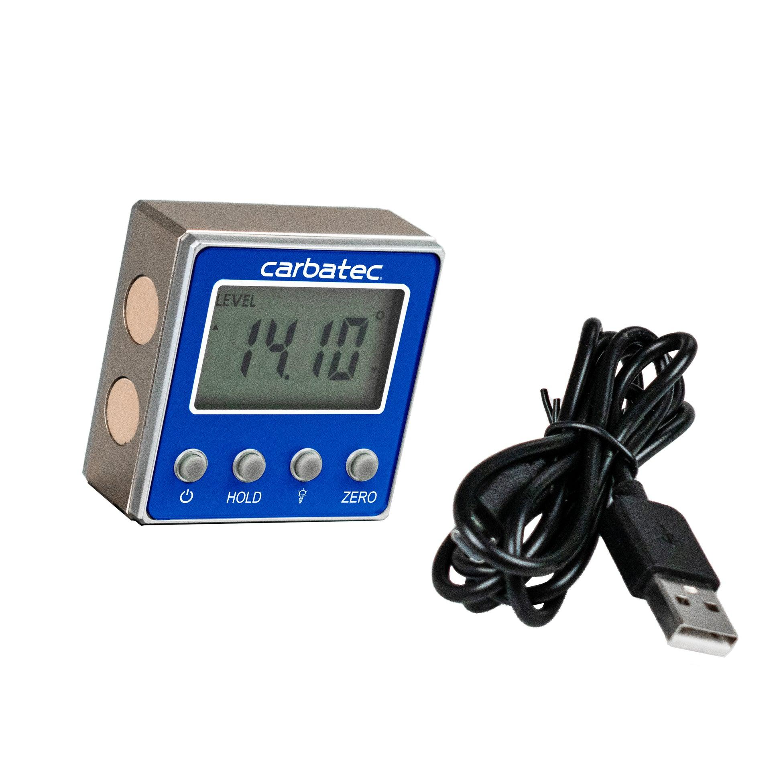
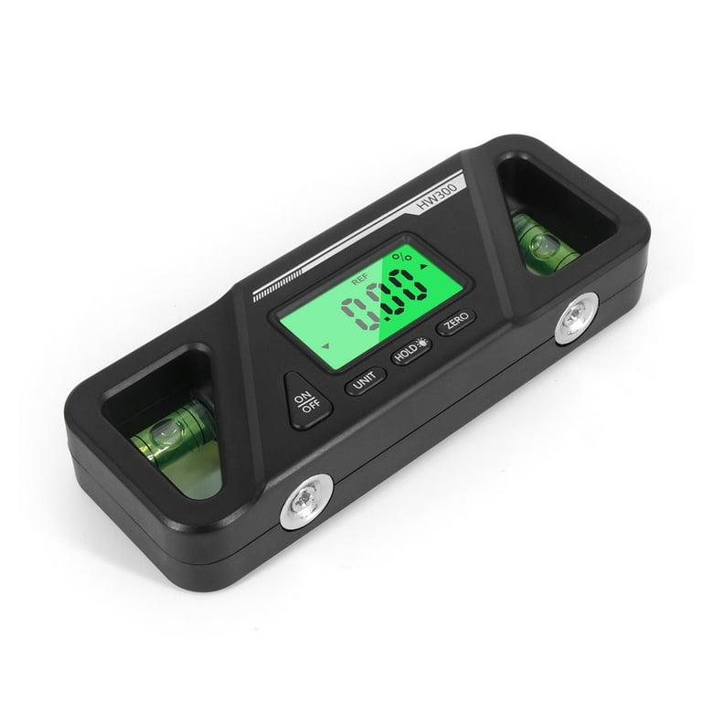
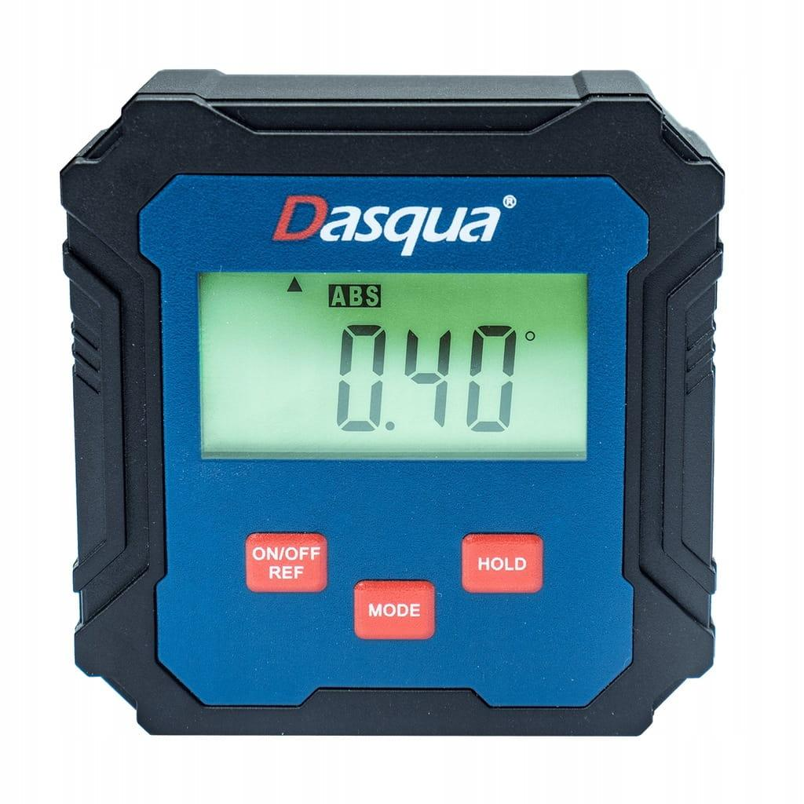
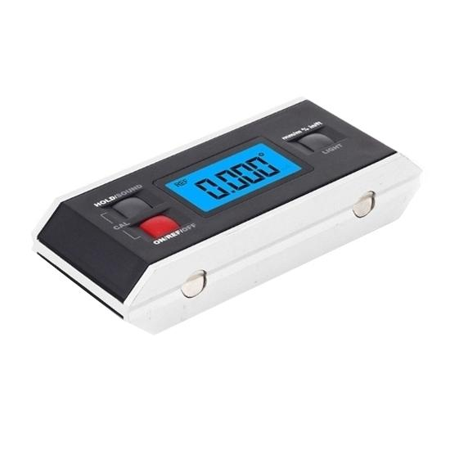
Description
Uses electronic sensors to provide highly accurate digital angle measurements.
Features
- LCD display
- Digital readout
- Zero calibration
- Hold function
- Metric/Imperial slope display (model dependent)
Applications
- Precision machining
- Engineering
- Construction
- CNC setup

3. Magnetic Angle Finder (Digital Inclinometer)
# Source: AI Source: Provided by: [Data Path: Persons Table -> ID Column: 1, Name_En Column: Motasem Essam] -> From: [ChatGPT] on [7/17/2026]
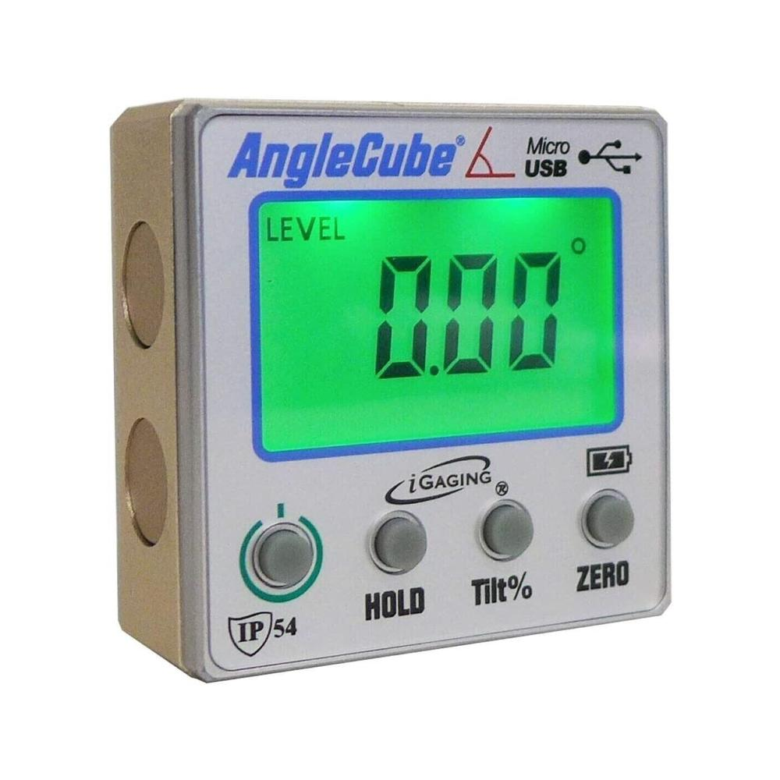
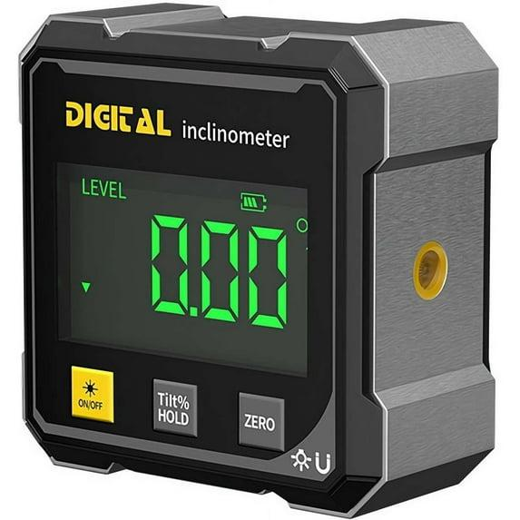
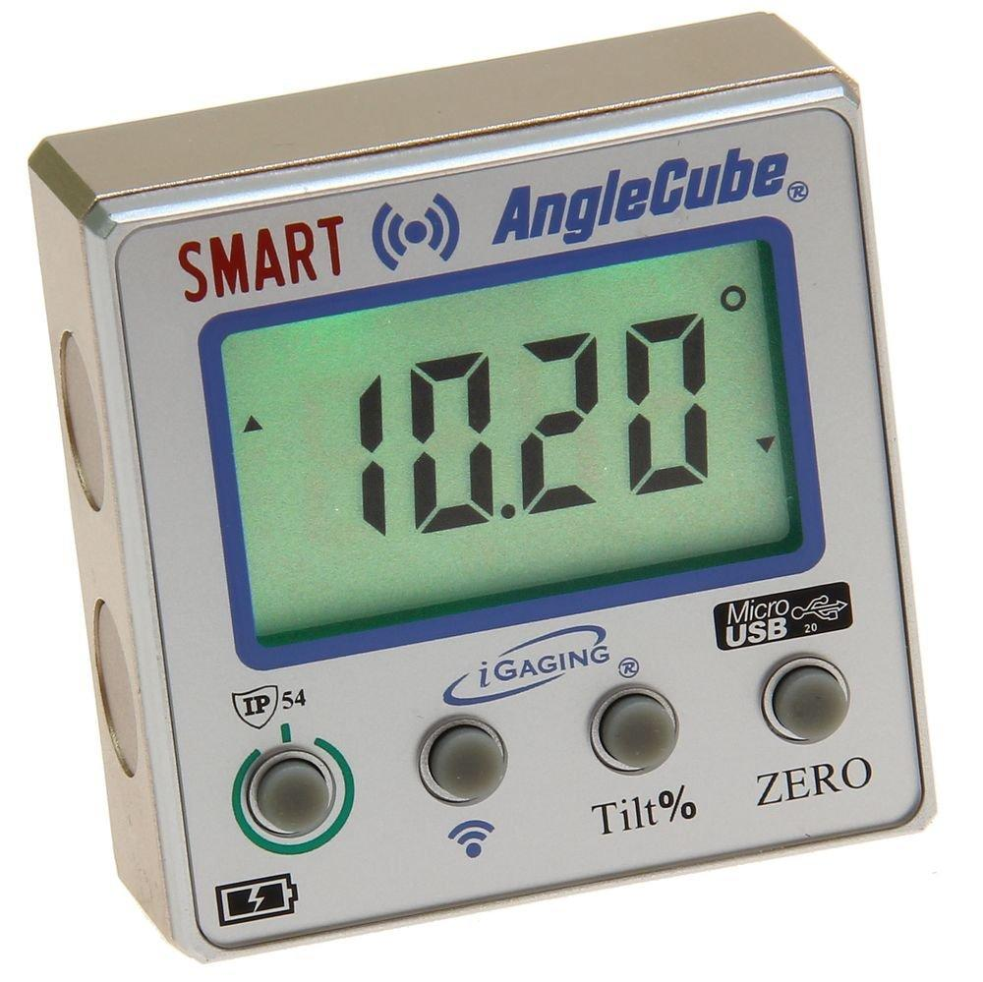
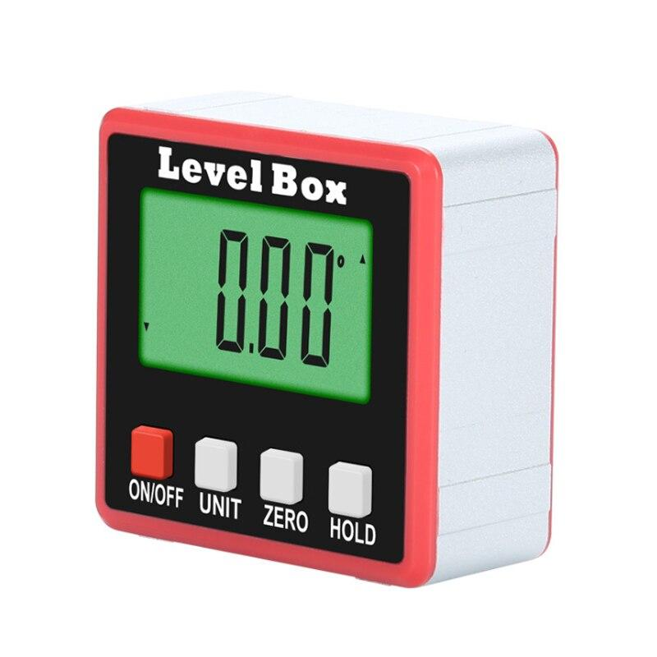
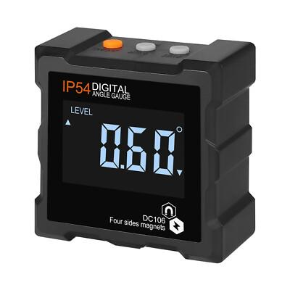
Description
A compact digital angle finder with magnetic surfaces that attaches directly to metal tools and machines.
Features
- Strong magnetic base
- LCD display
- High precision
- Compact size
Applications
- Table saw setup
- Milling machines
- Drill presses
- Machine alignment

4. Combination Angle Finder
# Source: AI Source: Provided by: [Data Path: Persons Table -> ID Column: 1, Name_En Column: Motasem Essam] -> From: [ChatGPT] on [7/17/2026]
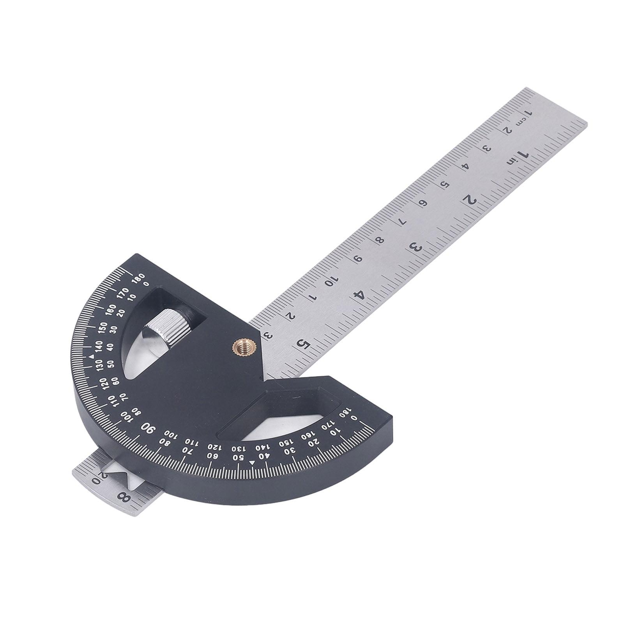
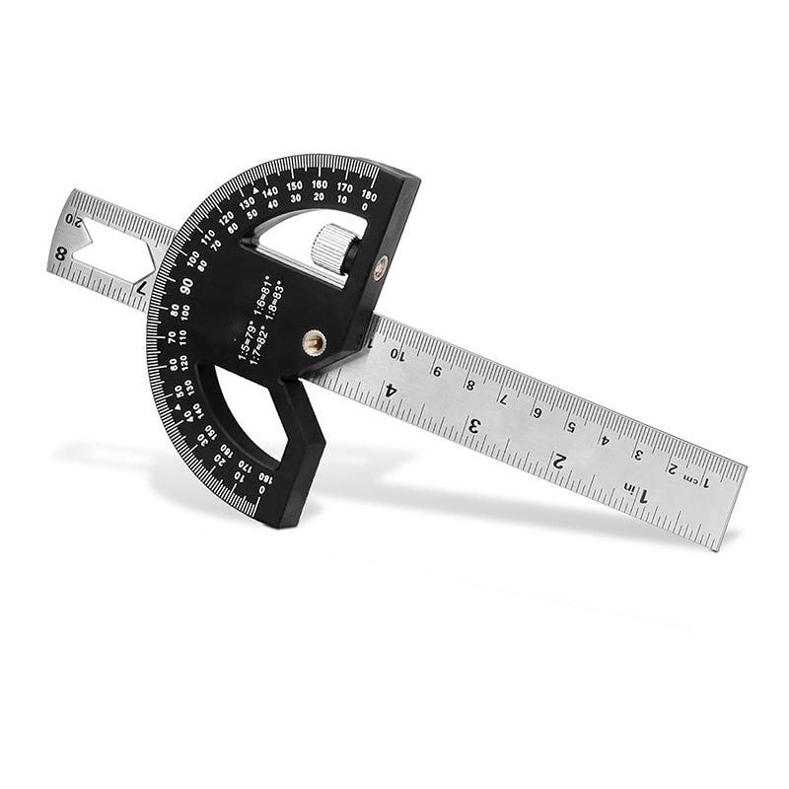

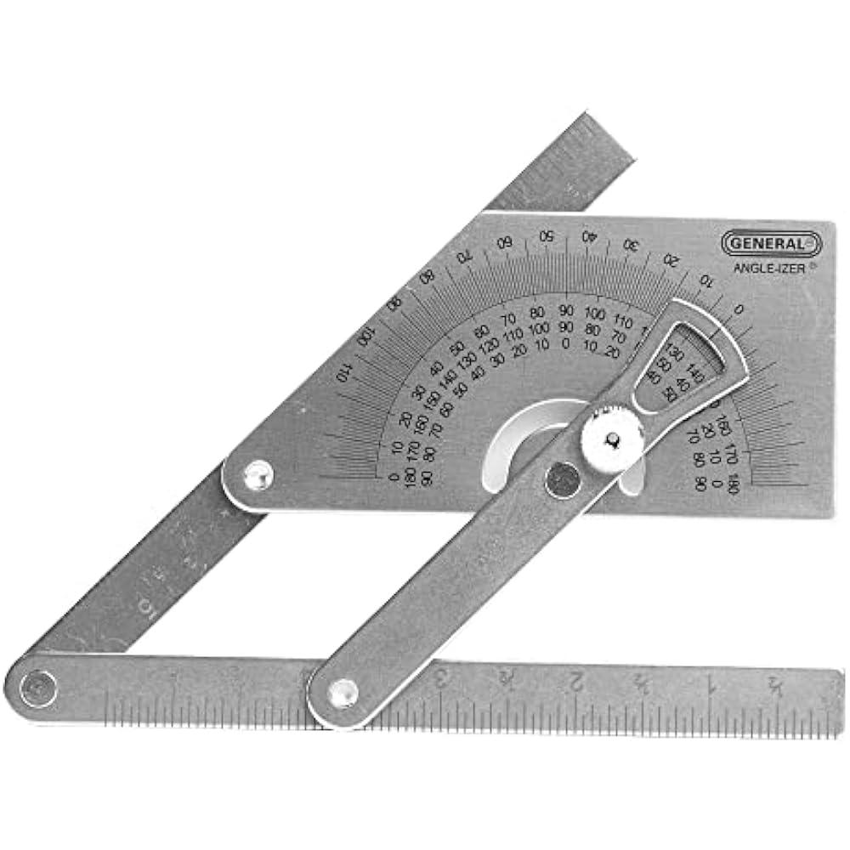
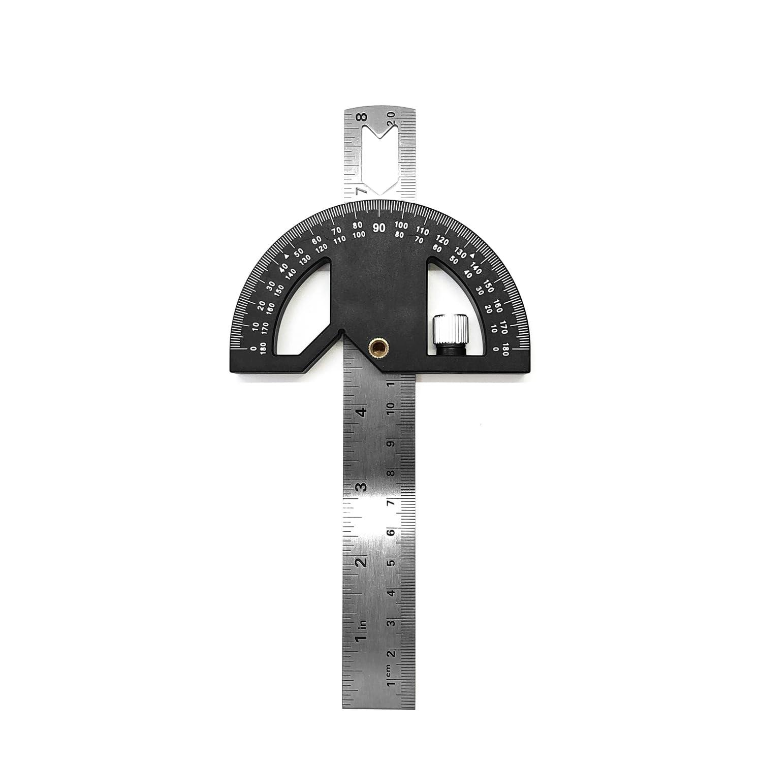
Description
Combines an angle finder with a ruler or protractor for measuring both lengths and angles.
Applications
- Drafting
- Construction
- Layout work
- Fabrication

Measuring Range
# Source: AI Source: Provided by: [Data Path: Persons Table -> ID Column: 1, Name_En Column: Motasem Essam] -> From: [ChatGPT] on [7/17/2026]
Typical measuring ranges:
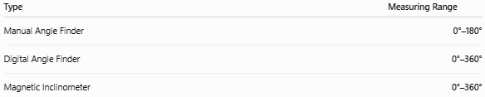
Type | Measuring Range
Manual Angle Finder | 0°–180°
Digital Angle Finder | 0°–360°
Magnetic Inclinometer | 0°–360°

Resolution
# Source: AI Source: Provided by: [Data Path: Persons Table -> ID Column: 1, Name_En Column: Motasem Essam] -> From: [ChatGPT] on [7/17/2026]
Typical resolutions:
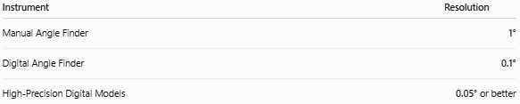
Instrument | Resolution
Manual Angle Finder | 1°
Digital Angle Finder | 0.1°
High-Precision Digital Models | 0.05° or better

How to Measure an Angle
# Source: AI Source: Provided by: [Data Path: Persons Table -> ID Column: 1, Name_En Column: Motasem Essam] -> From: [ChatGPT] on [7/17/2026]
- Open the measuring arms.
- Place each arm against one of the two surfaces.
- Ensure full contact with both surfaces.
- Lock the arms if required.
- Read the angle from the scale or digital display.
- Record the measurement.

Example
# Source: AI Source: Provided by: [Data Path: Persons Table -> ID Column: 1, Name_En Column: Motasem Essam] -> From: [ChatGPT] on [7/17/2026]
Suppose the display shows:
47.8°
The measured angle is:
$$\boxed{{47.8}^{∘}}$$

Accuracy
# Source: AI Source: Provided by: [Data Path: Persons Table -> ID Column: 1, Name_En Column: Motasem Essam] -> From: [ChatGPT] on [7/17/2026]
Typical accuracy:
- Manual: ±1°
- Digital: ±0.2°
- Precision digital models: ±0.1°
Accuracy depends on:
- Calibration
- Sensor quality
- Surface contact
- Operator technique

Sources of Error
# Source: AI Source: Provided by: [Data Path: Persons Table -> ID Column: 1, Name_En Column: Motasem Essam] -> From: [ChatGPT] on [7/17/2026]
Instrument Errors
- Loose pivot
- Worn scale
- Sensor calibration drift
- Low battery (digital models)

Observation Errors
- Reading the wrong scale
- Misinterpreting the display
- Recording errors

Positioning Errors
- Arms not fully contacting the surfaces
- Instrument movement
- Improper alignment

Environmental Errors
- Dirt between contact surfaces
- Strong vibration
- Temperature changes affecting electronic sensors

Applications
# Source: AI Source: Provided by: [Data Path: Persons Table -> ID Column: 1, Name_En Column: Motasem Essam] -> From: [ChatGPT] on [7/17/2026]
Angle Finders are used in:
- Carpentry
- Woodworking
- Construction
- Civil engineering
- Mechanical engineering
- Metalworking
- CNC machining
- Pipe installation
- Roofing
- Quality inspection

Advantages
# Source: AI Source: Provided by: [Data Path: Persons Table -> ID Column: 1, Name_En Column: Motasem Essam] -> From: [ChatGPT] on [7/17/2026]
An Angle Finder:
- Measures angles quickly.
- Transfers angles accurately.
- Portable and easy to use.
- Digital models provide direct readings.
- Suitable for field and workshop use.

Limitations
# Source: AI Source: Provided by: [Data Path: Persons Table -> ID Column: 1, Name_En Column: Motasem Essam] -> From: [ChatGPT] on [7/17/2026]
An Angle Finder:
- Manual models have lower precision than digital versions.
- Digital models require batteries.
- Sensor calibration may be needed periodically.
- Magnetic models only attach to ferromagnetic materials.

Comparison with Other Angle Measuring Instruments
# Source: AI Source: Provided by: [Data Path: Persons Table -> ID Column: 1, Name_En Column: Motasem Essam] -> From: [ChatGPT] on [7/17/2026]
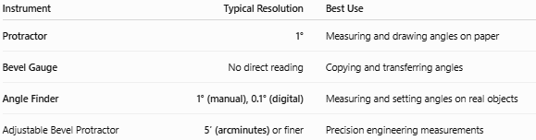
Instrument | Typical Resolution | Best Use
Protractor | 1° | Measuring and drawing angles on paper
Bevel Gauge | No direct reading | Copying and transferring angles
Angle Finder | 1° (manual), 0.1° (digital) | Measuring and setting angles on real objects
Adjustable Bevel Protractor | 5′ (arcminutes) or finer | Precision engineering measurements

Care and Maintenance
# Source: AI Source: Provided by: [Data Path: Persons Table -> ID Column: 1, Name_En Column: Motasem Essam] -> From: [ChatGPT] on [7/17/2026]
To maintain accuracy:
- Keep the measuring surfaces clean.
- Tighten locking mechanisms properly.
- Replace batteries when needed.
- Store in a protective case.
- Calibrate digital models periodically.
- Avoid dropping the instrument.

Common Mistakes
# Source: AI Source: Provided by: [Data Path: Persons Table -> ID Column: 1, Name_En Column: Motasem Essam] -> From: [ChatGPT] on [7/17/2026]
- Measuring with loose arms.
- Not zeroing the digital display before use.
- Holding the tool at an angle to the surfaces.
- Allowing dirt or debris to affect contact.
- Forgetting to lock the arms before transferring an angle.

Key Points
# Source: AI Source: Provided by: [Data Path: Persons Table -> ID Column: 1, Name_En Column: Motasem Essam] -> From: [ChatGPT] on [7/17/2026]
- An Angle Finder measures and transfers angles between surfaces.
- Common types:
  - Manual Angle Finder
  - Digital Angle Finder
  - Magnetic Digital Inclinometer
  - Combination Angle Finder
- Measuring range:
  - 0°–180° (manual)
  - 0°–360° (digital)
- Typical digital resolution:
  - 0.1°
- Widely used in construction, engineering, woodworking, machining, and inspection.

Conclusion
# Source: AI Source: Provided by: [Data Path: Persons Table -> ID Column: 1, Name_En Column: Motasem Essam] -> From: [ChatGPT] on [7/17/2026]
An Angle Finder is a versatile angle-measuring instrument used to measure, set, verify, and transfer angles directly on physical objects and structures. Available in manual and digital versions, it offers fast and reliable angular measurements for applications ranging from carpentry and woodworking to precision engineering and machine setup. Digital angle finders, particularly magnetic inclinometers, provide high-resolution readings and have become essential tools in modern construction, manufacturing, and quality control.

